

**Lab Report 1**

**Submitted To**

**Faculty Name :** Md. Manowarul Islam

**Associate Professor, Dept. of CSE**

**Submitted By**

**Name :** Sheikh Sarafat Hossain

**Id No :** 2022-3-60-109

**Course Title :** Data Structures

**Course Code :** CSE207

**Section :** 07

**Semester :** Fall 2023

**Date of Submission:** 05 November, 2023

**Report on Array Manipulation in Data Structure Programming**

**Introduction:**

A collection of code examples that show basic array manipulation algorithms used in Data Structure courses has been included in this report. Basic operations like as sorting, finding the second maximum and second minimum values, identifying duplicates, removing elements, adding new elements, reversing arrays, looking for palindromes are all presented in these examples. Now let's explore each of these coding exercises.

**Bubble Sort: Sorting an Array**

The Bubble Sort algorithm, an essential sorting technique, is explained in the first code sample. It counts the number of swaps made during sorting correctly organizes elements in Ascending order.

This is the Algorithm which I Used to Sorting an Array.

**Finding Second Maximum and Second Minimum:**

The second sample, which finds the second maximum and second minimum values in an array, teaches us about data analysis and finding extreme values.

This is the Algorithm which I Used to Sorting an Array.

**Finding Duplicate Elements:**

Within an array, duplicate elements can be found using the third piece of code. It provides useful understanding of array traversing and recognition of patterns.

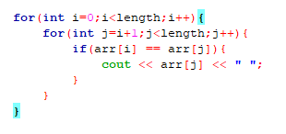

This is the Algorithm which I Used to Sorting an Array.

**Deleting an Element from an Array:**

The method to delete an element from an array at a given location is shown in the fourth code example. It's a simple process that changes the array size correctly.

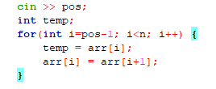

This is the Algorithm which I Used to Sorting an Array.

**Inserting an Element into an Array:**

The insertion of a new element to an array at the specified location is shown in the fifth code sample. To make room for the new value, it moves elements, generating a modified array.

This is the Algorithm which I Used to Sorting an Array.

**Checking for Palindromes:**

The array's palindrome status is checked in the sixth algorithm. It helps with working in array modification and string comparison by reversing the array and comparing it to the original.

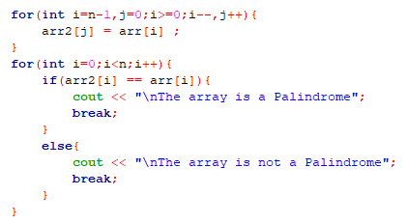

This is the Algorithm which I Used to Sorting an Array.

**Reversing an Array:**

The final code example reverses the order of elements in an array and displays them in reverse. This operation is a valuable exercise in array modification, helping to understand the rearrangement of data.

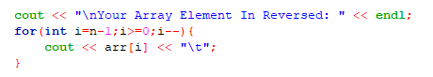

This is the Algorithm which I Used to Sorting an Array.

**Conclusion:**

These little pieces of code are essential for learning how to manipulate arrays in a data structure course. They act as the basis for more complicated algorithms and data structures. Being expert in these basic operations is essential for any programmer to have. A fundamental component of computer science and programming, array manipulation is responsible for many real-world tasks.